

**Project IDEATIONS**

Some apps to ponder

1) App to help alcoholics

<http://www.techtimes.com/articles/4854/20140326/smartphone-app-help-alcoholics-on-the-road-to-recovery.htm>

2) App for monitoring fetus (and having fetus listen to music like Beethoven)

<http://blogs.wsj.com/digits/2014/03/03/app-system-turns-a-phone-into-a-fetal-monitor/>

3) App for monitoring the elderly

http://www.slate.com/blogs/future_tense/2015/11/17/the_care_mind_app_uses_fitbits_to_monitor_the_elderly.html

4) Internet of Things

<http://bits.blogs.nytimes.com/2014/03/27/consortium-wants-standards-for-internet-of-things/?_php=true&_type=blogs&_r=0>

 Other ideas

* chat room
* random quote of the day
* HELP DESK TICKET
* Health - metrics
* netcom app -- net commands, sonar pings
* earthquake alarmer
* calculator – financial,math,scientific,taxes,tips...



**APP features**

* use of mysql/sqllite
* maps
* accelerators
* sensors
* screen orientations
* AV
* Progress bar
* push notification (GCM)– G
* analytics-G
* Google Play or Fake site – G
* Junit Testing - G

Your Ideas?

[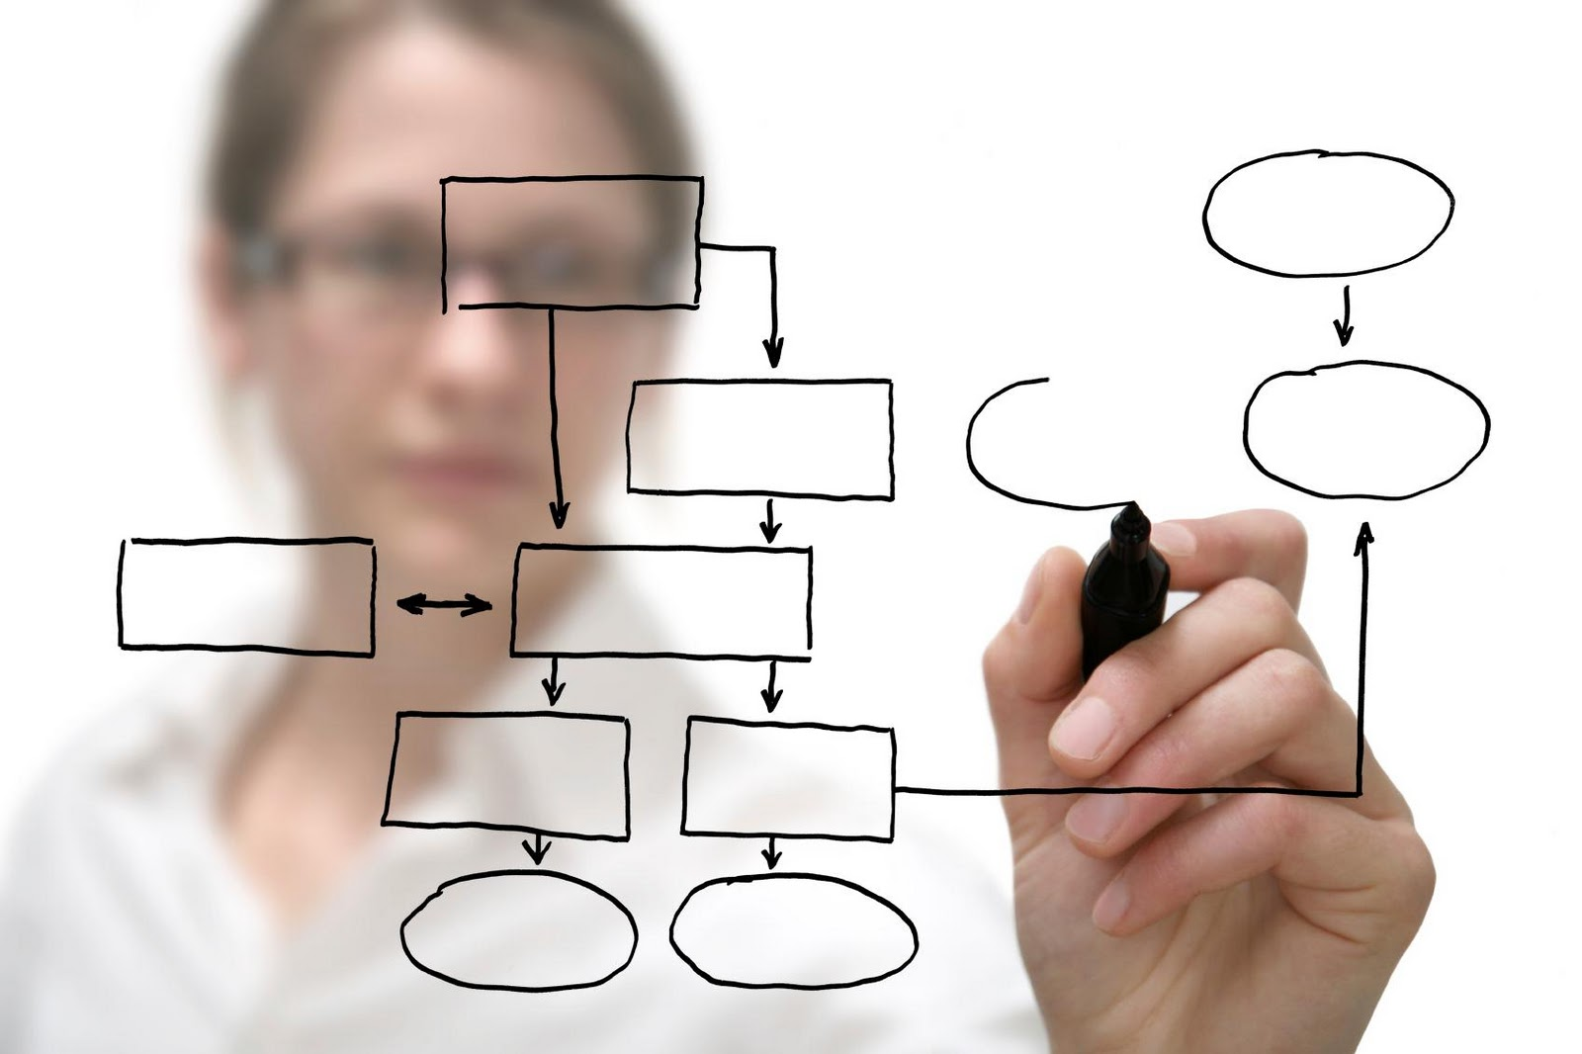](http://www.papademas.net/php_android_project/index.php)